Ideation Phase
Define the Problem Statements

Date | 30 September 2026
Team ID | SWTID-2026-4717
Project Name | AI Weather Wise
Maximum Marks | 2 Marks

Customer Problem Statement Template:
Create a problem statement to understand your customer's point of view. The Customer Problem Statement template helps you focus on what matters to create experiences people will love.
A well-articulated customer problem statement allows you and your team to find the ideal solution for the challenges your customers face. Throughout the process, you’ll also be able to empathize with your customers, which helps you better understand how they perceive your product or service.
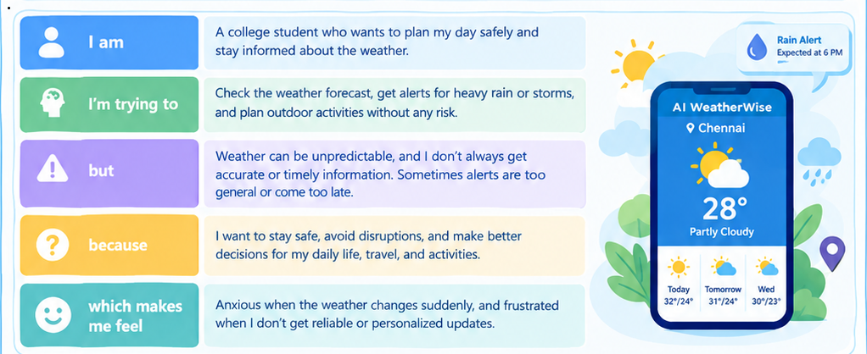
Example:
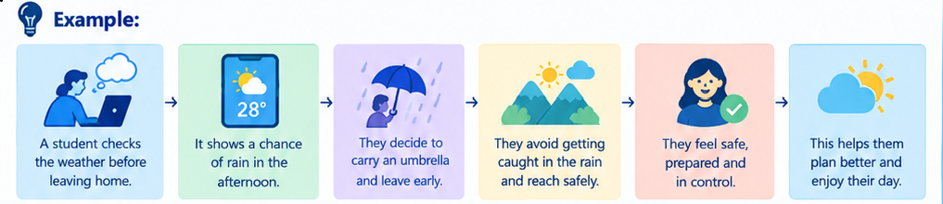
Problem Statement (PS) | I am (Customer) | I’m trying to | But | Because | Which makes me feel
PS-1 | College Student | Check Weather and plan my day | Weather is unpredictable and alerts are late | I want to stay safe and avoid disruptions | Anxious and frustrated
PS-2 | Traveler | Find safe travel times and route suggestions | Sudden storms or poor weather conditions | I want a smooth and safe journey | Uncertain and worried
PS-3 | Working Professional | Plan my daily commute | Weather conditions can change during travel | I need reliable weather information to avoid delays and inconvenience | Stressed and concerned
PS-4 | Outdoor Activity User | Decide whether it is safe to exercise or attend an outdoor event | Rain, strong winds, or extreme temperatures may occur unexpectedly | I want to enjoy outdoor activities safely | Concerned and hesitant
PS-5 | Farmer | Monitor weather conditions for farming activities | Weather changes can affect crops and agricultural work | I need timely weather information to make better decisions | Worried and uncertain
PS-6 | Family / Parent | Keep my family prepared for severe weather | Weather warnings may be difficult to understand or may arrive late | I want to protect my family and plan ahead | Concerned but prepared
PS-7 | Elderly Use | Understand the weather easily | Weather applications can provide too much complex information | I need simple and clear weather guidance | Confused and uncomfortable

